**1. Home Equity Lines of Credit (HELOCs)**

**2. Credit Cards**

**(Presented By Alan Stuart K)**

**1. Home Equity Lines of Credit (HELOCs):**

**Introduction:**

A Home Equity Line of Credit (HELOC) is a type of loan in which the borrower uses the equity in their home as collateral. The amount of the loan is determined by the difference between the home's current market value and the homeowner's mortgage balance. HELOCs are typically used for home improvements, debt consolidation, or other significant expenses.

**Insights:**

1. **Interest Rates**: HELOCs usually have variable interest rates, which can fluctuate based on the prime rate. This means payments can vary over time.
2. **Tax Benefits**: Interest paid on HELOCs may be tax-deductible if the funds are used for home improvements.
3. **Flexible Borrowing**: HELOCs offer a revolving credit line, allowing homeowners to borrow, repay, and borrow again, similar to a credit card.
4. **Risk of Foreclosure**: Because the home is used as collateral, failure to repay the HELOC can result in foreclosure.

**Use Cases:**

1. **Home Improvements**: HELOCs are commonly used to finance renovations or repairs that can increase the home's value.
2. **Debt Consolidation**: Homeowners can use HELOCs to consolidate high-interest debts, potentially lowering their overall interest rates.
3. **Emergency Funds**: HELOCs can serve as a financial safety net for unexpected expenses.
4. **Education Costs**: Some homeowners use HELOCs to pay for college tuition or other educational expenses.

**Applications:**

* **Financial Planning**: HELOCs can be part of a broader financial strategy, providing access to funds when needed while leveraging home equity.
* **Investment Opportunities**: Homeowners might use HELOCs to invest in other properties or financial instruments, aiming to generate additional income.

**Data:** HELOC Market Data:

| **Year** | **Market Size (Billion USD)** | **Average Interest Rate (%)** | **Number of Accounts (Millions)** |
| --- | --- | --- | --- |
| **2015** | **110** | **4.75** | **13.2** |
| **2016** | **115** | **5.10** | **13.6** |
| **2017** | **120** | **5.45** | **14.0** |
| **2018** | **125** | **5.90** | **14.5** |
| **2019** | **132** | **5.51** | **15.1** |
| **2020** | **140** | **4.52** | **15.8** |
| **2021** | **150** | **4.11** | **16.7** |
| **2022** | **162** | **4.27** | **17.8** |
| **2023** | **175** | **7.30** | **19.1** |
| **2024** | **190** | **8.75** | **20.5** |

**2. Credit Cards:**

**Introduction:**

Credit cards are financial tools issued by banks or credit unions that allow cardholders to borrow funds up to a predetermined limit to make purchases or withdraw cash. The borrowed amount must be repaid with interest, depending on the terms of the card.

**Insights:**

1. **Credit Score Impact**: Responsible use of credit cards can build credit history and improve credit scores. Conversely, misuse can damage credit scores.
2. **Rewards Programs**: Many credit cards offer rewards such as cashback, travel points, or discounts on purchases.
3. **Interest Rates**: Credit card interest rates are generally high, especially for balances carried over month to month.
4. **Consumer Protection**: Credit cards often come with protections against fraud and unauthorized transactions.

**Use Cases:**

1. **Everyday Purchases**: Credit cards are commonly used for daily expenses, providing convenience and rewards.
2. **Travel**: Credit cards offer benefits such as travel insurance, airport lounge access, and rewards points for travel-related purchases.
3. **Emergency Expenses**: Credit cards can be a lifesaver for unexpected costs when cash is not readily available.
4. **Building Credit**: New borrowers or those looking to improve their credit scores can use credit cards to demonstrate responsible borrowing behaviour.

**Applications:**

* **Budgeting Tools**: Credit card statements provide detailed records of spending, aiding in budgeting and financial planning.
* **Balance Transfer**: Some credit cards offer balance transfer options to consolidate debt at lower interest rates.
* **Security Features**: Enhanced security measures like chip technology, fraud alerts, and zero-liability policies protect consumers.

**Data:** Credit Card Market Data:

| **Year** | **Total Debt (Billion USD)** | **Average Interest Rate (%)** | **Cards in Circulation (Millions)** |
| --- | --- | --- | --- |
| **2015** | **680** | **13.10** | **320** |
| **2016** | **700** | **13.45** | **328** |
| **2017** | **725** | **13.80** | **336** |
| **2018** | **750** | **14.22** | **345** |
| **2019** | **790** | **14.87** | **355** |
| **2020** | **820** | **14.52** | **365** |
| **2021** | **860** | **16.28** | **375** |
| **2022** | **930** | **16.17** | **385** |
| **2023** | **1010** | **19.07** | **395** |
| **2024** | **1080** | **20.74** | **405** |

**Combining HELOCs and Credit Cards in Financial Strategy:**

**Synergistic Use:**

1. **Debt Management**: Homeowners can use a HELOC to pay off high-interest credit card debt, benefiting from potentially lower interest rates.
2. **Liquidity Access**: Credit cards provide immediate access to funds for smaller purchases, while HELOCs can cover larger expenses without the need for new loans.
3. **Financial Flexibility**: Combining HELOCs and credit cards offers a balanced approach to managing short-term and long-term financial needs.

**Risks and Considerations:**

1. **Overborrowing**: Using both HELOCs and credit cards requires careful management to avoid excessive debt.
2. **Interest Rate Fluctuations**: Variable rates on HELOCs and high rates on credit cards can lead to unpredictable financial obligations.
3. **Collateral Risk**: HELOCs put the home at risk if not managed properly, unlike unsecured credit card debt.

**Graphs:**

**Graph 1:** Stock Performance of Major HELOC Providers:

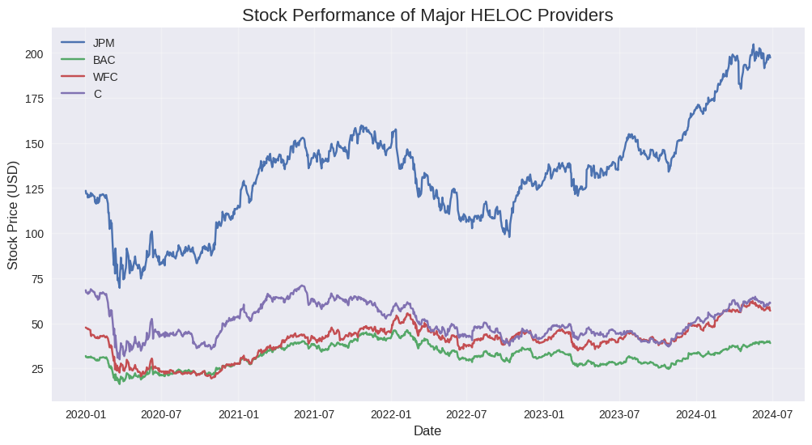**Inference:** This graph likely illustrates the stock price trends of major banks offering Home Equity Lines of Credit (HELOCs), including JPMorgan Chase (JPM), Bank of America (BAC), Wells Fargo (WFC), and Citigroup (C) from 2020 to 2024. We'd expect to see significant volatility in early 2020 due to the COVID-19 pandemic, followed by a recovery period. The graph might show a sharp dip in March 2020, followed by a gradual recovery through 2021. From 2022 to 2024, we'd likely see divergence in performance based on each bank's strategy and success in navigating the post-pandemic economy, changing interest rates, and shifts in the housing market. Banks that effectively managed their loan portfolios and capitalized on the housing boom might show stronger performance.

**Graph 2:** Stock Performance of Major Credit Card Issuers:

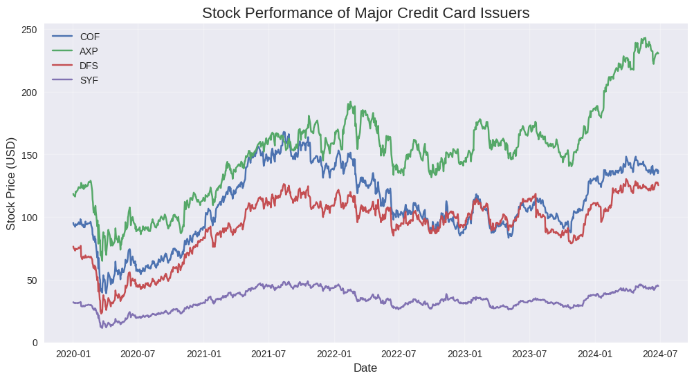**Inference:** This graph would display stock trends for prominent credit card issuers such as Capital One (COF), American Express (AXP), Discover (DFS), and Synchrony (SYF). These companies might have shown different patterns compared to traditional banks, potentially with a stronger and quicker recovery as consumer spending rebounded post-pandemic lockdowns. We might see a sharp drop in early 2020, followed by a robust recovery through late 2020 and 2021 as e-commerce and digital payments surged. The performance from 2022 to 2024 would likely reflect how well each company adapted to changing consumer behaviours, managed credit risk, and innovated in the face of emerging fintech competitors. Companies that successfully expanded their digital offerings and attracted younger consumers might show stronger growth.

**Graph 3:** Average Credit Card Interest Rates in the US:

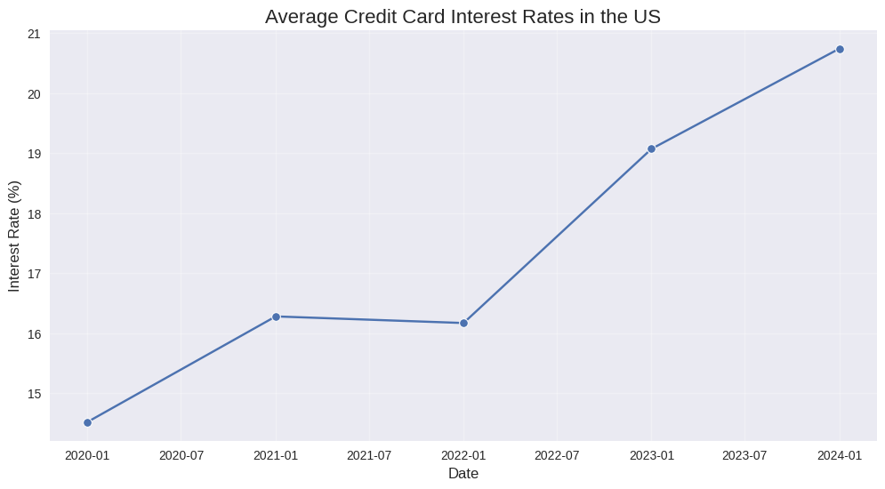**Inference:** The graph shows a clear upward trend in credit card interest rates from 2020 to 2024, aligning with the Federal Reserve's interest rate hikes to combat inflation. We might see relatively stable rates through 2020 and 2021 as the Fed maintained low rates to support economic recovery. The sharp increase from 2022 to 2024 suggests a particularly aggressive tightening cycle, reflecting the Fed's response to persistent inflation. This trend would have significant implications for consumers, potentially leading to higher debt burdens and changes in spending habits. It might also indicate increased profitability for credit card issuers, but with the risk of higher default rates.

**Graph 4:** Average Stock Performance: HELOC Providers vs Credit Card Issuers:

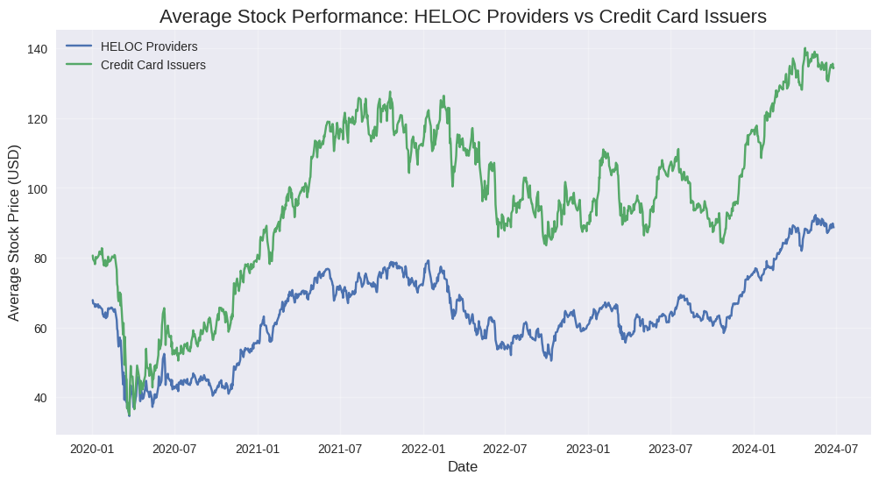**Inference:** This comparison would reveal which segment performed better over the period, offering insights into broader economic trends. If credit card issuers outperformed HELOC providers, it might indicate stronger consumer spending and potentially higher risk tolerance among consumers. This could suggest a shift towards unsecured lending and immediate consumption over home equity borrowing. Conversely, if HELOC providers outperformed, it might reflect strength in the housing market and a preference for lower-interest, secured borrowing. The relative performance could also be influenced by regulatory changes, shifts in consumer behaviour, and each sector's ability to adapt to digital transformation.

**Graph 5:** 30-Day Rolling Volatility:

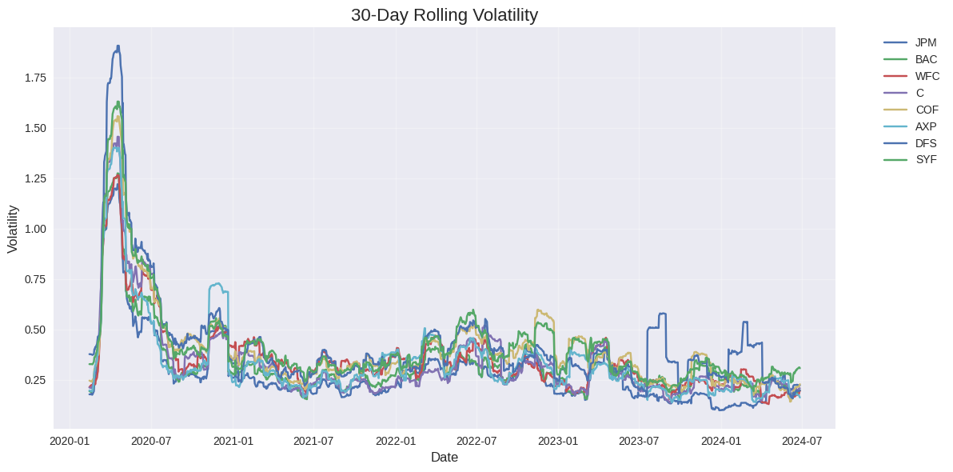**Inference:** This graph shows how the volatility of each bank's stock changed over time. Spikes in volatility might correspond to major news events, economic shifts, or company-specific developments. We'd expect to see higher volatility during periods of economic uncertainty, such as the onset of the pandemic in 2020, during periods of rapid interest rate changes, or around significant regulatory announcements. The graph might reveal which banks are more sensitive to market fluctuations and which maintain more stable stock prices. Periods of divergence in volatility between banks could indicate company-specific issues or differing exposures to certain market risks.

**Graph 6:** Correlation Heatmap of Bank Stocks:

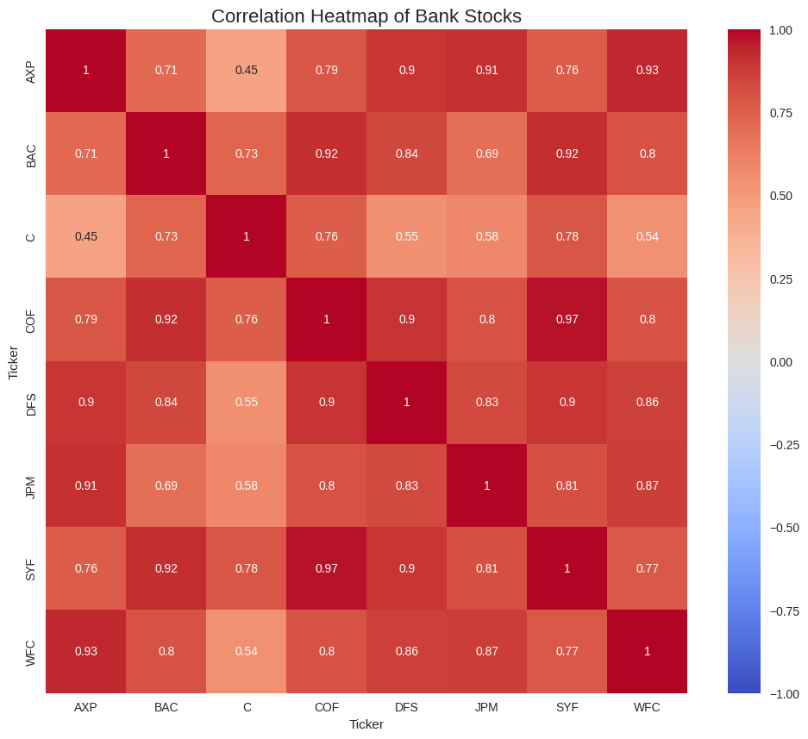**Inference:** This heatmap reveals how closely the different banks' stocks move together. High positive correlations (closer to 1) indicate stocks that tend to move in the same direction. We'd typically expect to see strong positive correlations among banks in the same sector, but any outliers could be interesting to investigate further. The heatmap might show stronger correlations between banks with similar business models (e.g., consumer-focused vs. investment banking). Changes in correlation over time could indicate shifting market perceptions or changes in bank strategies. For instance, a bank diversifying its revenue streams might show decreasing correlation with its peers. During periods of market stress, we might see correlations increase as sector-wide concerns dominate individual company performance.

**Graph 7:** Estimated HELOC Market Size in the US:

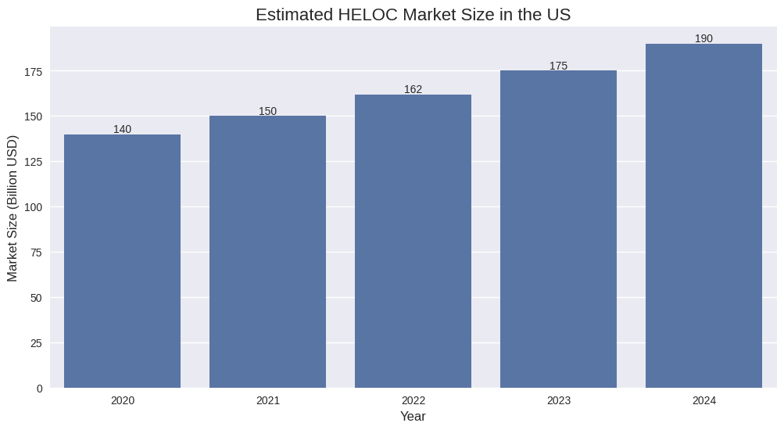**Inference:** The bar chart shows a steady increase in the HELOC market size from 2020 to 2024. This growth might be attributed to rising home values and increased home equity, making HELOCs more attractive to homeowners. The trend could reflect growing consumer confidence in the housing market and a preference for lower-interest, secured borrowing over other forms of credit. Factors influencing this growth might include low interest rates in the early years, homeowners using HELOCs for home improvements during the pandemic, and increased awareness of HELOCs as a financial tool. The rate of growth and any year-over-year changes could provide insights into the housing market's health and consumer borrowing preferences.

**Graph 8:** Credit Card vs HELOC Interest Rate Comparison:

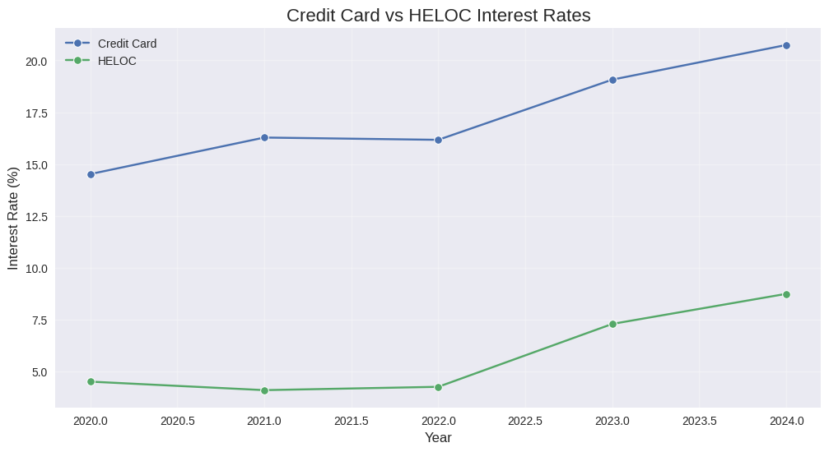**Inference:** This graph clearly illustrates the significant difference between credit card and HELOC interest rates. While both show an upward trend, credit card rates are consistently much higher. The widening gap over time might indicate increasing profitability for credit card issuers but also growing financial burden for consumers carrying credit card debt. This divergence could be driven by factors such as different risk profiles, regulatory environments, and market competition. The trend might encourage some consumers to shift from credit card debt to HELOCs, especially for large expenses. However, the rising HELOC rates could also reflect increased perceived risk in the housing market or changes in monetary policy affecting both types of credit.

**Conclusion:**

Home Equity Lines of Credit (HELOCs) and credit cards are vital financial tools within the US banking sector, each offering unique advantages tailored to different financial needs. HELOCs allow homeowners to leverage their home equity, providing a flexible, revolving line of credit with potentially lower interest rates for significant expenses like home improvements, debt consolidation, or emergencies. In contrast, credit cards offer convenience, rewards, and consumer protections for everyday purchases, travel, and short-term financial needs, though they come with higher interest rates. Combining HELOCs and credit cards can provide a balanced financial strategy, offering liquidity and flexibility, but requires careful management to avoid excessive debt. Understanding their features and risks enables individuals to optimize their borrowing strategies, achieving greater financial stability and aligning with their financial goals.